**Rotational Dynamics**

**ABSTRACT:** This experiment studied the rotational dynamics which are analogous to objects moving in a linear line by measuring the angular quantities with one and two rotating disks and an external force that exerts torque on the system. The change in angular velocity, angular acceleration and torque is then used to investigate and validate the relations among these quantities. The kinematics and dynamics of a rotating object was fully described by using these angular quantities.

Report written by: Tamer Avci

Lab partner: Bharath Shankar

November 6, 2013

**INTRODUCTION**: The relations among angular velocity, acceleration and torque are perfectly analogous to the linear dynamics. First and foremost, there is a displacement which can be described by θ. This is measured in radians. Parallel to the linear dynamics, the first derivative of the angular displacement with respect to time is the angular velocity ω and the second derivative with respect to time is the angular acceleration α. Newton’s second law is also valid in angular dynamics, however it yields a different kind of force and mass: τ = I α

I is the moment of inertia and it depends on how the mass is distributed throughout the object. For a solid, uniform disk that is used in the experiment, the moment of inertia is

I = ½ MR^2 where R is the radius and M is the mass of the disk is.

Similar to linear dynamics, as long as the torque is constant there is a constant acceleration that is associated with it. Hence, this equation can be used:

w (t) = $ω_{0}+ αt$

In the experiment, the linearity of this function is tested with one and two rotating disks, and the quantities are investigated respectively.

**PROCEDURE**: The main equipment for this experiment is the Rotational Dynamics Apparatus (RDA). Using recalibration mass on the balance the masses of the steel disks are measured and their radii are recorded. Then, the masses of the aluminum spool and the falling mass are weighted. The electrical power supply of the RDA, the Y-connector as well as ULI must all be connected before we can begin the experiment. Next, the RDA is to be leveled using the screws on the bottom of the RDA.

The disks require compressed air to rotate freely and the air must be supplied at 9 psi. After supplying the air, the two disks must be placed on the spindle. The larger aluminum spoon must come on top of the upper steel disks. The hollow thumbscrew must be gently tightened and the hole in the thumbscrew must be plugged with the drop pin. By doing so, the upper disk should rotate freely, whereas the bottom disk will remain stationary.

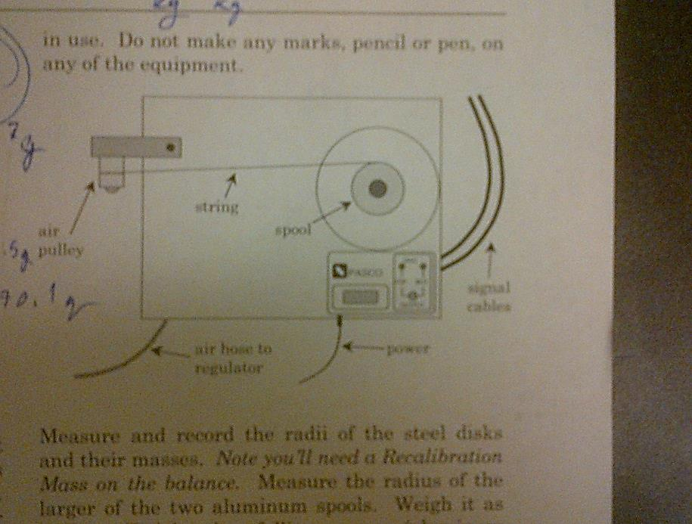The torque will be applied by the falling mass connected to the spool by the string. The falling mass should not hit the bottom when the string is unwound. The disks have black and white bars and one need to count the number of black bars, so that the LOGGER Pro software measures the time it takes for a black bar and a white bar to move past the photo gate, which is its angular velocity. With the air pressure at 9psi, the falling mass must be winded up close to the air pulley and the disk must be hold with a starting white bar at the photo gate and then released. This procedure is conducted 15 times with one disk rotating and it is followed by one time with two disks rotating. The LOGGER PRO generates the following tables without the average velocities:

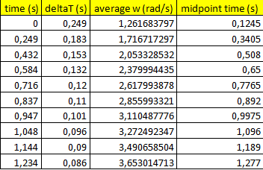**One disk rotating**:

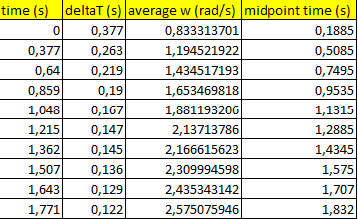**Two disks rotating:**

Initially, the tables did not have the midpoint times either. In order to calculate angular velocity the following formula must be used:

w(t) = 2 * PI / N * deltaT

Before we can proceed to drawing the graphs we need one other quantity. Although we have the average velocity for specific time points, they do not represent the time points we have in the first time column. We need to calculate a new time column to correct for this issue, because obviously the first average velocity does not refer to the time = 0 s.

As shown in the image above t=0, and t= 0.249 refer to the beginning of the black bars. The average velocities, however, refer to the points with stars. That is why we have to calculate another quantity called the midpoint time:

Midpoint time1 (s) = (t0+t1) / 2

For the first midpoint it is also obviously = deltaT1 / 2

Since we have the correct time values, now we can sketch graphs. They are given right next to the graphs. The last step of the procedure is finding the uncertainty in angular acceleration that results from the one disk rotating trials. Angular acceleration is the first derivative of the angular velocity with respect to time. Hence, it is the slope of the graphs sketched above. Using these 15 trials we can execute statistical analysis of uncertainties.

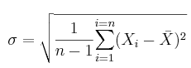

After writing down all the angular acceleration data from 15 trials, we find the mean value. This is X. Next we calculate Xi – X for each trial and get the sum. N stands for the number of trials conducted. After we figure out what is, we use this formula to get the proper plus or minus value to put on an average:

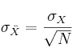

The mean value in our experiment was: 2.12 with the standard deviation of .01

The same procedure is followed for the two disks rotating experiment.

**RESULTS AND ANALYSIS:**

The angular acceleration of one disk is:

$$α=2.12 ± .01 \frac{rad}{s^{2}}$$

The angular acceleration of two disks together is:

$$α=1.07 ± .01 \frac{rad}{s^{2}}$$

The free body diagrams, showing all the relevant forces, for the disk and the falling mass are presented below:

The derivation for the theoretically expected angular acceleration of the disk is:

The equation we used in the procedure : w(t) = 2* PI / N* deltaT is true becauseN stands for the number of black bars. DeltaT is the time that took each white and black bar couple to move past the photo gate. By using displacement/time formula, we can get the angular velocity. Note that we use the angular displacement 2 * PI, which represents one full cycle.

**CONCLUSION**: The following conclusions can be drawn from the obtained data: The acceleration measured with two rotating disks is almost half the size of the acceleration of one rotating disk. Furthermore, there is a small discrepancy between the measured and theoretical acceleration.

$$α_{measured}=2.12 ± .01 \frac{rad}{s^{2}}$$

$$α_{measured}=1.07 ± .01 \frac{rad}{s^{2}}$$

$${ α}_{theoretical}= 2.28 \frac{rad}{s^{2}}$$

$$α_{theoretical}= 1.16 \frac{rad}{s^{2}}$$

This is due to inevitable kinetic friction between the disks and the air friction. Another reason that might have also played a role in this difference is the unavoidable unlevelness of the system.